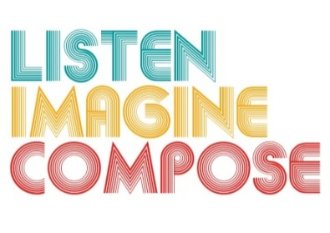
SCHEME OF WORK 4: How do we introduce music to young people that they don’t already know and make it relevant to their learning with reference to both musical and extra-musical contexts?

LESSON 2 EVALUATION

Key Questions:

How confident were learners’ in performing their ideas? How can you increase learner confidence?

What teaching strategies did you employ to encourage creative learning?

Did learners’ develop their understating and knowledge of rhythmic awareness and compositional structures? If so, how? If not, how can you support learners?

What went well in the lesson?

What have you learnt from the assessments that will assist future lessons?

