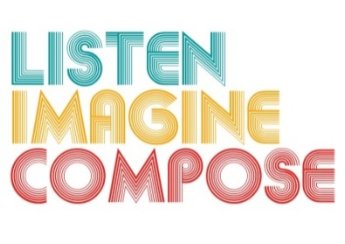
SCHEME OF WORK 4: How do we introduce music to young people that they don’t already know and make it relevant to their learning with reference to both musical and extra-musical contexts?

LESSON 1 EVALUATION

Key Questions:

How successful were you introducing ‘Worm Gear (Gadget III)’ to the learners?

Did the learners understand the musical concepts behind the work of ‘Worm Gear’? If not, why? How can you extend this next lesson?

Were learners able to personalise their learning? Could they relate their work to personal experiences?

How musical are the learning intentions for this lesson, and how clearly do they articulate the quality of expected musical response from the pupils?

How quickly did the learners’ engage with musical sound at the start of the lesson? Were their any learning barriers? If so, how did you overcome these?

