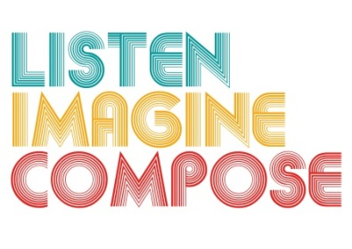
SCHEME OF WORK 3: What is the role of listening and reflection in the creative process?

LESSON 6 EVALUATION

Key Questions:

How effective were the recordings for telling you about the musical progress that the learners made?

What evidence is there of pupils’ increased musical understanding and responses?

Was the lesson objectives met? If so, How? If not, why?

What went well in this lesson?

How could this lesson be extended via homework or out of school contexts?

