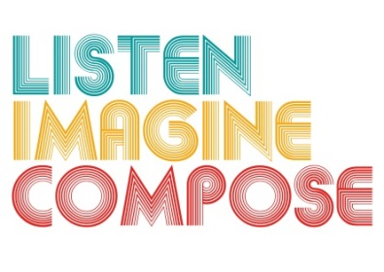
SCHEME OF WORK 3: What is the role of listening and reflection in the creative process?

LESSON 3 EVALUATION

Key Questions:

How well did the learners’ work in groups?

How successful was reflection in the lesson for improved learning?

Did recording the performances help learners evaluate their progress?

How well did pupils achieve the lesson objectives and what evidence can I provide about the groups achievements?

What went well in the lesson? Why?

What have you learnt that will help you in future lessons?

