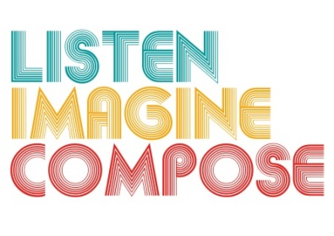
SCHEME OF WORK 3: What is the role and listening and reflection in the creative process?

LESSON 2 EVALUATION

Key Questions:

Have the learners listening skills developed over the last two lessons? If so, how? If not, why?

Did the learners take creative risks in the lesson? If so, How did you encourage this? What could you do differently next time?

How well did pupils achieve the lesson objectives and what evidence can I provide about individual achievement?

What went well in the lesson? Why?

What have you learnt that will help you in future lessons?

