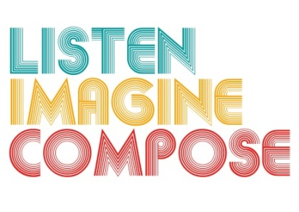
SCHEME OF WORK 2: What processes for evaluating pupil work can be adopted to give constructive feedback and encourage peer review?

LESSON 1 EVALUATION

Key Questions:

How successful were you introducing the work of Thelonius Monk?

Were learners able to evaluate their own learning? If so, how? If not why?

How musical are the learning intentions for this lesson, and how clearly do they articulate the quality of expected musical response from the pupils?

How quickly did the learners’ engage with musical sound at the start of the lesson? Were their any learning barriers? If so, how did you overcome these?

What went well in the lesson? Why?

