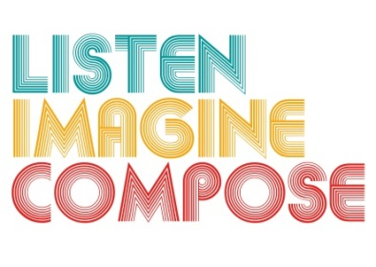
SCHEME OF WORK 1: What pedagogic strategies are there for creative learning in music?

LESSON 6 EVALUATION

Key Questions:

How well did the learners perform their pieces?

Did the learners’ realise their creative ideas?

Was the lesson objectives met? If so, How? If not, why?

What went well in this lesson?

How could this lesson be extended via homework or out of school contexts?

