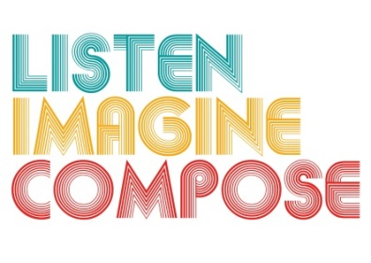
SCHEME OF WORK 1: What pedagogic strategies are there for creative learning in music?

LESSON 5 EVALUATION

Key Questions:

What teaching strategies did you employ to help learners reflect on their learning? Were you successful? If not, what could you do differently next time?

Are learners acting and thinking like composers? If not, not how can you support learners to reach this objective?

How successful were the collaborations in the lesson?

What evidence is there that pupils have experienced creative learning processes?

What evidence is there of pupils’ increased musical understanding and responses?

