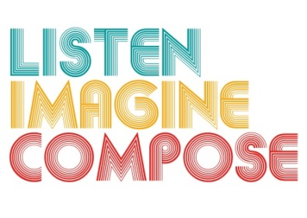
SCHEME OF WORK 1: What pedagogic strategies are there for creative learning in music?

LESSON 4 EVALUATION

Key Questions:

Are learners beginning to think like composers? How? If not, what teaching strategies can you employ to support learners?

How successful were the collaborations in the lesson?

Did the lesson assessments help you identify learning? If so, how? If not, why?

What went well in the lesson?

How could this lesson be extended via homework or out of school contexts?

