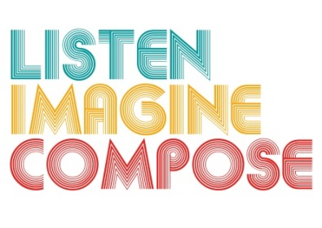
SCHEME OF WORK 1: What pedagogic strategies are there for creative learning in music?

LESSON 3 EVALUATION

Key Questions:

How well did your planning ensure a range if musical activity with continuity and progression?

How successful were you in employing a range of teaching strategies that encouraged creative learning?

Are learners working like composers and artistic directors? If so what evidence do you have of this? If not, how can you develop this next lesson?

What went well in the lesson?

What have you learnt about the learners’ musical knowledge and understanding that will inform lesson 4?

