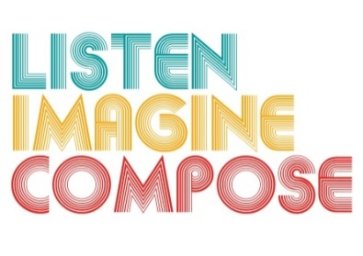
SCHEME OF WORK 1: What pedagogic strategies are there for creative learning in music?

LESSON 2 EVALUATION

Key Questions:

Has the learners understanding and knowledge of layers in composition developed over the last two lessons? If so, how? If not, why?

Did the learners reflect on their learning? If so, how did you encourage this? What could you do differently next time?

How well did pupils achieve the lesson objectives and what evidence can I provide about individual achievement?

What went well in the lesson? Why?

What have you learnt that will help you in future lessons?

