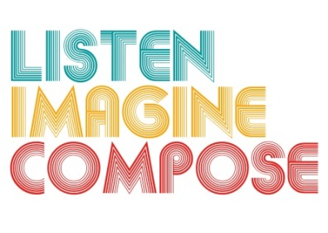
SCHEME OF WORK 1: What pedagogic strategies are there for creative learning in music?

LESSON 1 EVALUATION

Key Questions:

How successful were you in introducing multi-layered textures to the learners?

Did learners’ develop their creative leadership skills? If so, how? If not why?

What teaching strategies did you employ to encourage learners to become more analytical in their responses? If you did not how could you encourage this next lesson?

What went well in the lesson?

What have you learnt about the learners musical knowledge from this lesson that can help you plan for lesson 2?

