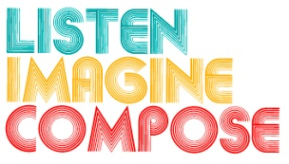
SCHEME OF WORK 3: What is the role of listening and reflection in the creative process?

LESSON 1 EVALUATION

Key Questions:

How did the learners respond to the visual stimuli as a starting point for making music?

How musical were the learners’ responses?

Did you encourage and respond to pupils’ creative, unexpected responses?

What evidence is there of pupils’ increased musical understanding and responses?

What went well in the lesson? Why?

What have you learnt that will help you in future lessons?

