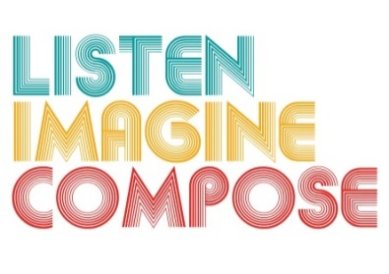
SCHEME OF WORK 6: How can technology be used to enhance creative thinking skills through composing?

LESSON 5 EVALUATION

Key Questions:

Were learners able to link together instruments with digital technology?

How creative were their compositions? How did you guide and help increase their learning?

What evidence is there that pupils have experienced creative learning processes?

What evidence is there of learners’ increased musical understanding and responses?

What was successful about the lesson?

