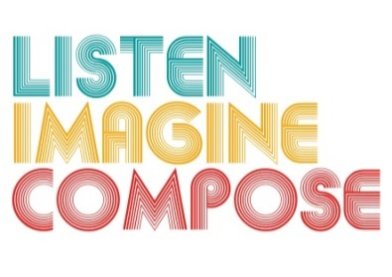
SCHEME OF WORK 6: How can technology be used to enhance creative thinking skills through composing?

LESSON 2 EVALUATION

Key Questions:

How did the learners respond to the music technology?

What teaching strategies did you employ to support learning using the music technology?

How well did learners work collaboratively?

Were learners able to mix sounds using music technology? How successful were they? What can you do expand on this next lesson?

Were the learning objectives met in the lesson? If so, how can you evidence this?

