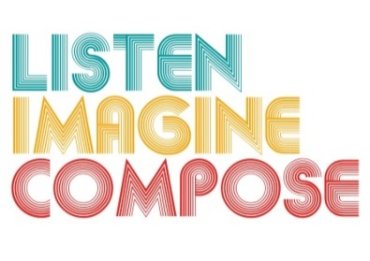
SCHEME OF WORK 6: How can technology be used to enhance creative thinking skills through composing?

LESSON 1 EVALUATION

Key Questions:

How successful were the learners in sharing their experiences and ideas? How can you develop this further next lesson?

How musical were the learners’ responses?

Were your instructions clear and my use of musical language appropriate?

What went well in the lesson? Why?

What have you learnt that will help you in future lessons?

