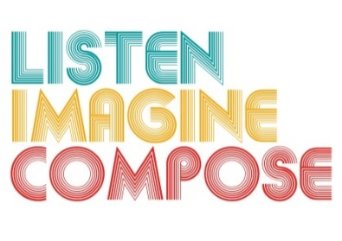
SCHEME OF WORK 5: How can Composers and Performers be best used as a resource in the classroom?

LESSON 3 EVALUATION

Key Questions:

How successful were lesson reflections? Did they help expand the learners’ notated compositions?

What do discussions with pupils tell you about the quality of their musical knowledge and understanding?

How well were the activities designed to enable pupils of all abilities and backgrounds to make a meaningful musical response?

Did the learners devise questions that will improve their notated composition? Did you help learners in this process? If so, how?

What went well in the lesson?

